**PLACEMENT MANAGEMENT**

**ABSTRACT**

The project named “Placement Management”, a student/teacher and developer information system is a web based system. The project is developed on the basis of a task used for retrieving the information of students and companies who can keep checking it on the website for details of jobs and internships which will be updated on a regular basis by the developers. It will maintain a large database of students wherein all the information of students like their sap id, department, academic year, contact number etc is stored and company information including about the companies and profile of the companies.The software retrieves this data and displays as per the user requirement.

The “Placement Management” is developed as an attempt to take a record of company and students by restricting such a large database to that of particular year of students or company.The students can search for their opportunities of job and aptitude tests of companies all in one webpage.

**PROBLEM STATEMENT**

While there are large number of students going for placements, need to prepare thoroughly for the interview. For this lot of research needs to be done to practice aptitude tests, doubts discussion, etc. It really becomes difficult for the students and finding to valid content on various sites, and a lot of time investment is need. There should be a common platform for teachers and students which will provide idea about various companies and aptitude tests.

1.Division of companies into dream, super dream along with their selection criteria in detail.

2.Mock aptitude tests on different topics

3.Teachers can solve all the doubts of the student

4.All recent updates of internship and placements will be provided on daily basis.

**INTRODUCTION**

This project is aimed at developing a web application for the Training and Placement Department of the college. The system is web application that can be accessed throughout the organization(by teachers as well as students) with proper login provided. This system can be used as a web application for the Training and Placement Officers of the college to manage the student information with regard to placement. The key feature of this project is that it is a one time registration. Our project provides maintaining the details of the students .Also,the students can surf about different companies according to Normal, Dream and Super Dream companies and could easily find each company’s aptitude tests, etc. Administrator logging in may also search any information put up by the students. This project will aid colleges to practice full IT deployment. This will also help in fast access procedures in placement related activities.

This website will help students in preparing for there placements also they will come to know about various companies and there work culture. Students can practice for aptitude tests.There are various topics that have

many multiple choice questions for practice, Students can also discuss there doubts regarding anything with the teachers.Students will get one hour of time to solve the aptitude test.

Since there is no proper platform for students to get to know about various companies (Category wise) and prepare for their placements all in one.Instead of searching for each company and then searching for aptitude questions differently ,this website provides altogether.

**ER DIAGRAM**

**ENTITIES AND THEIR ATTRIBUTES:**

**1.Students**- Name, Sap id, Email id, Contact no. ,Department, Year

Primary key- Email Id, Contact number, Sap Id

**2.Companies**- Requirements, Name, LPA, Types

Primary key- Name

**3.Mock Tests**- Id, Name, Category, Links.

Primary Key- Id, Name

**4.Teachers**- Name, Email Id

Primary Key-Email Id

**5.Questions**- Id, Title, A, B, C, D, Correct Answer

Primary Key-Id

**CARDINALITY AND PARTICIPATION:**

**1.Students-Search-Companies**: M:N , Students are totally participating and companies are partially participating.

**2.Companies-Has-Mock Tests**: 1:M, Both Companies and Mock Tests are totally participating.

**3.Mock Tests-Contains-Questions**: M:N, Both Mock Tests and Questions are totally participating.

**4.Students-Dicuss Doubts-Teachers**: M:N, Both Students and Teachers are partially participating.

**ER DIAGRAM:**

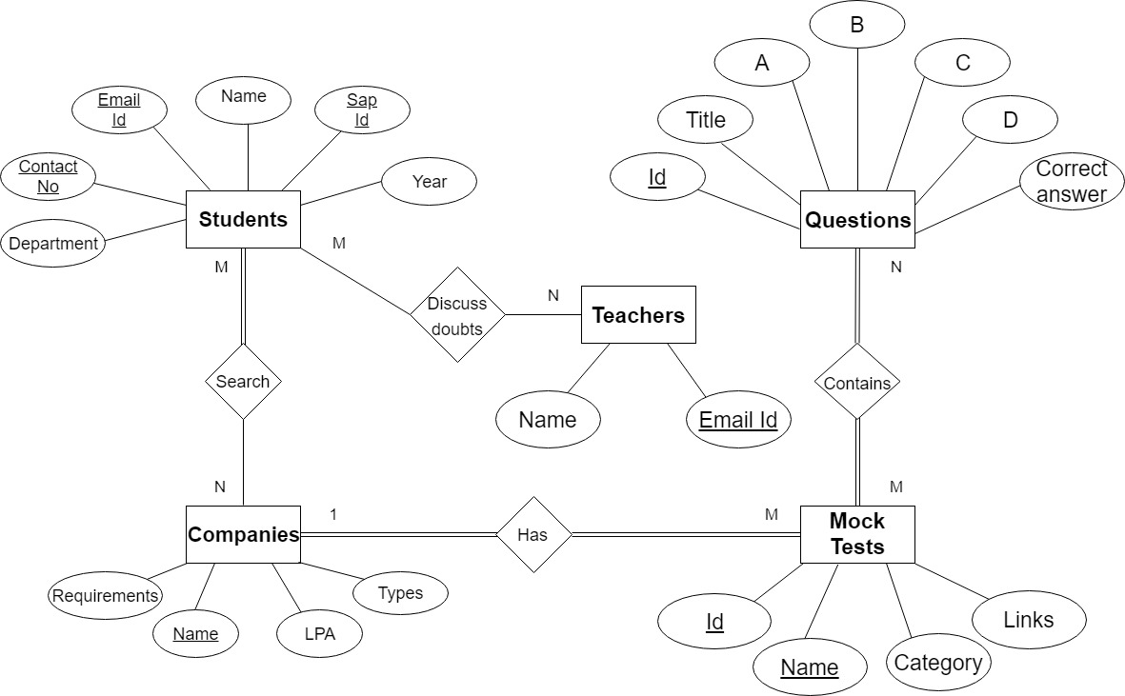

**RELATIONAL SCHEMA**

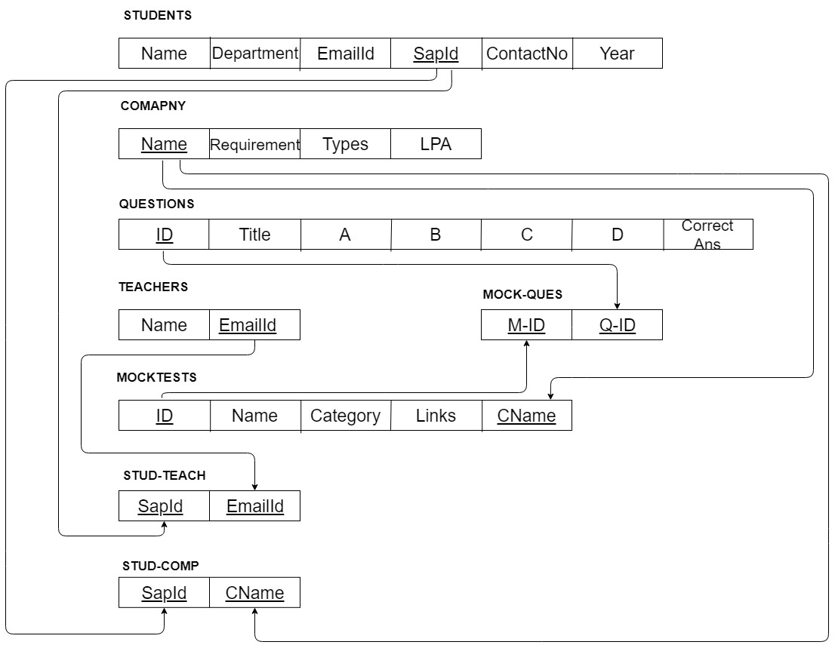

**IMPLEMENTATION**

**Home page**

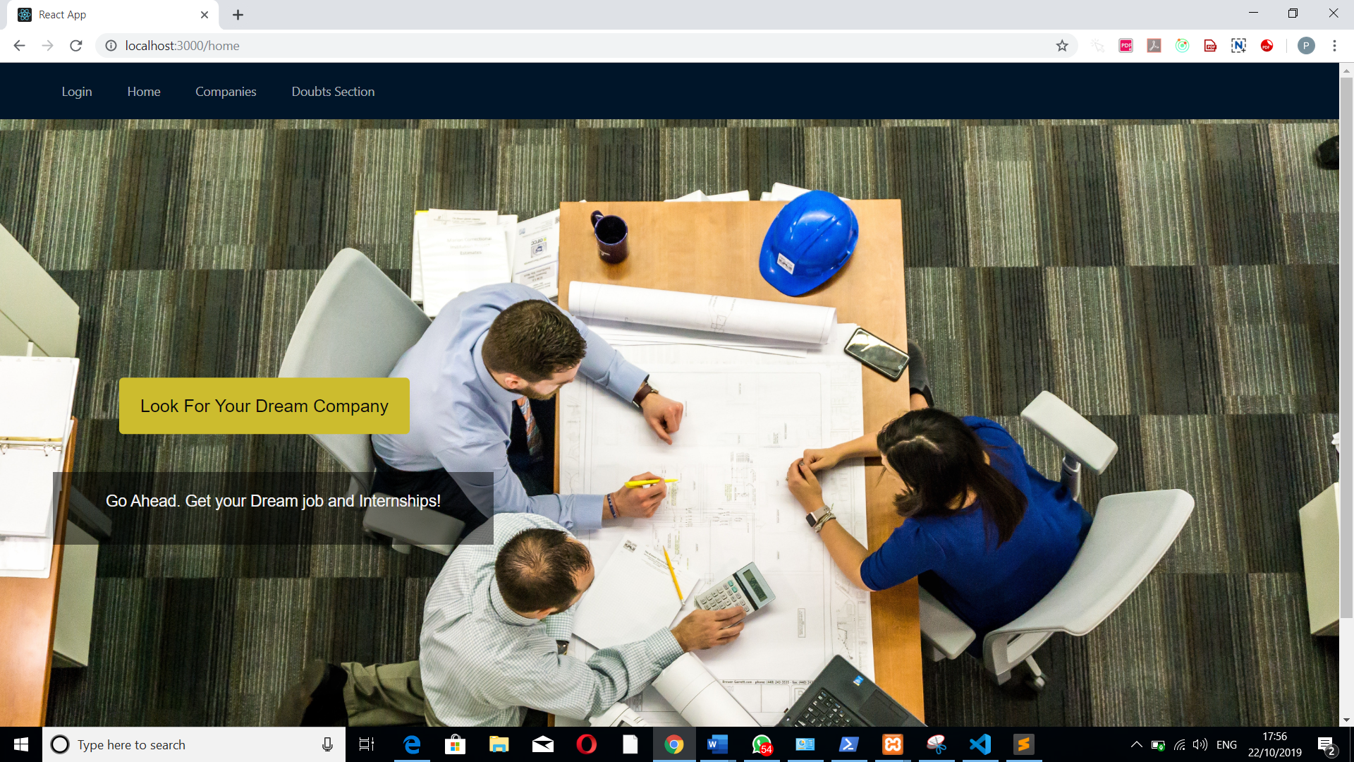

**Companies page**

Companies are divided as per there categories.Students will get to know about different companies and their work culture .

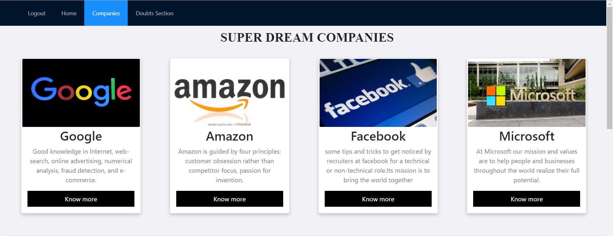

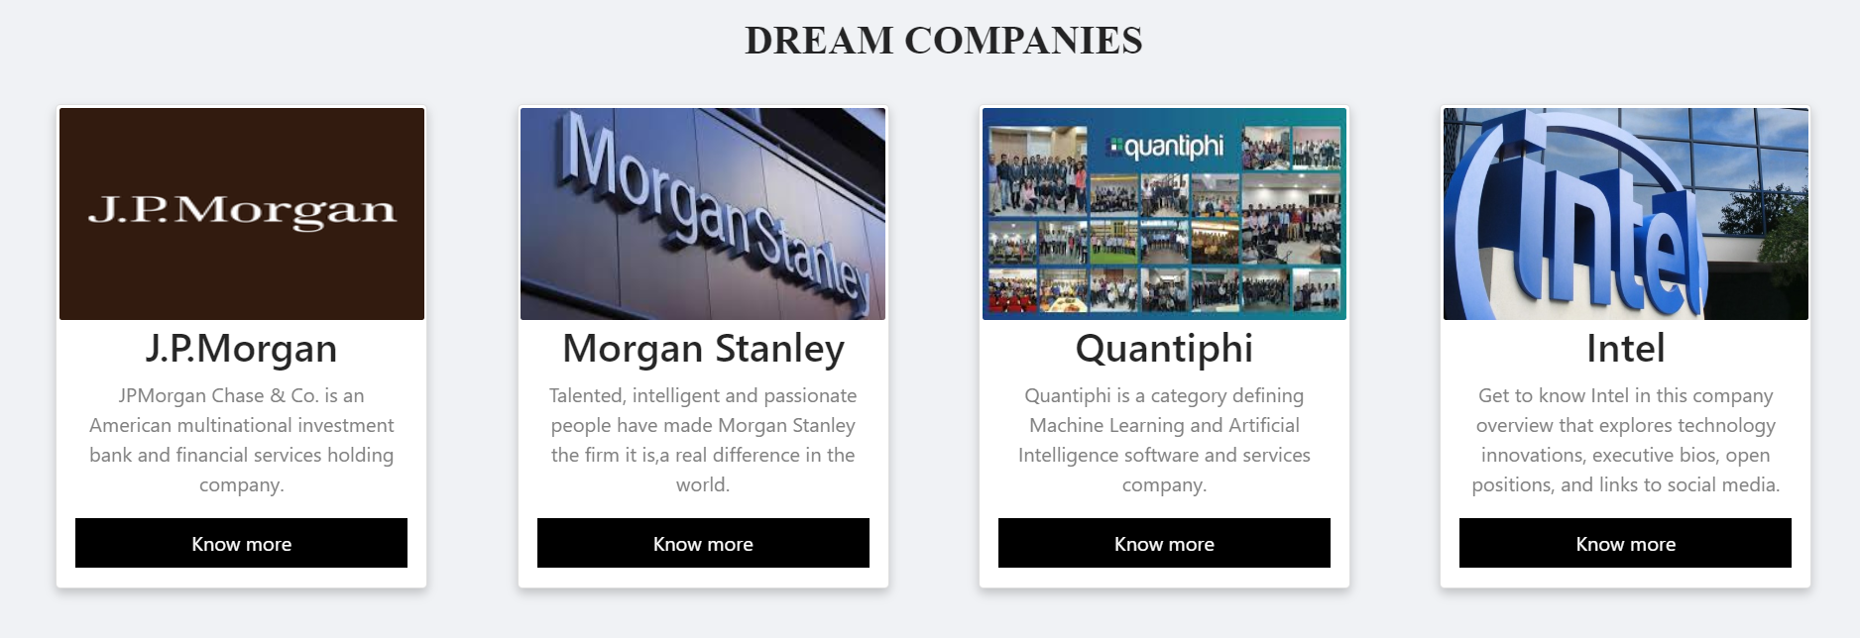

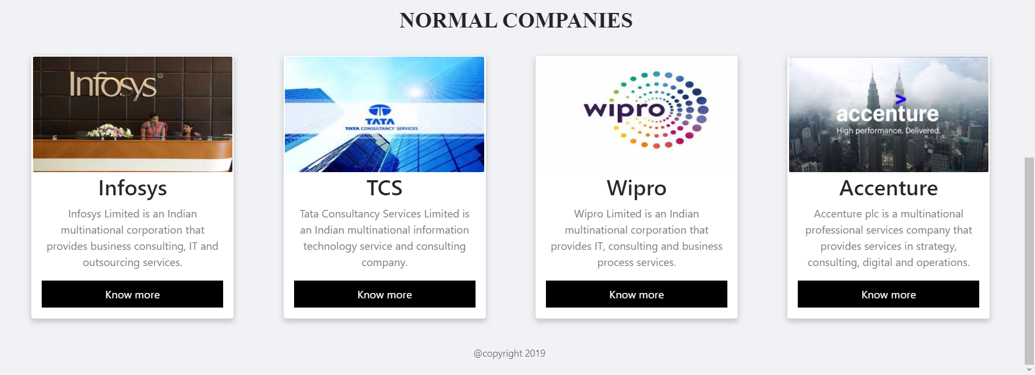

**Morgan Stanley Company page**

Students can get to know about the company and what kind of work that company does.

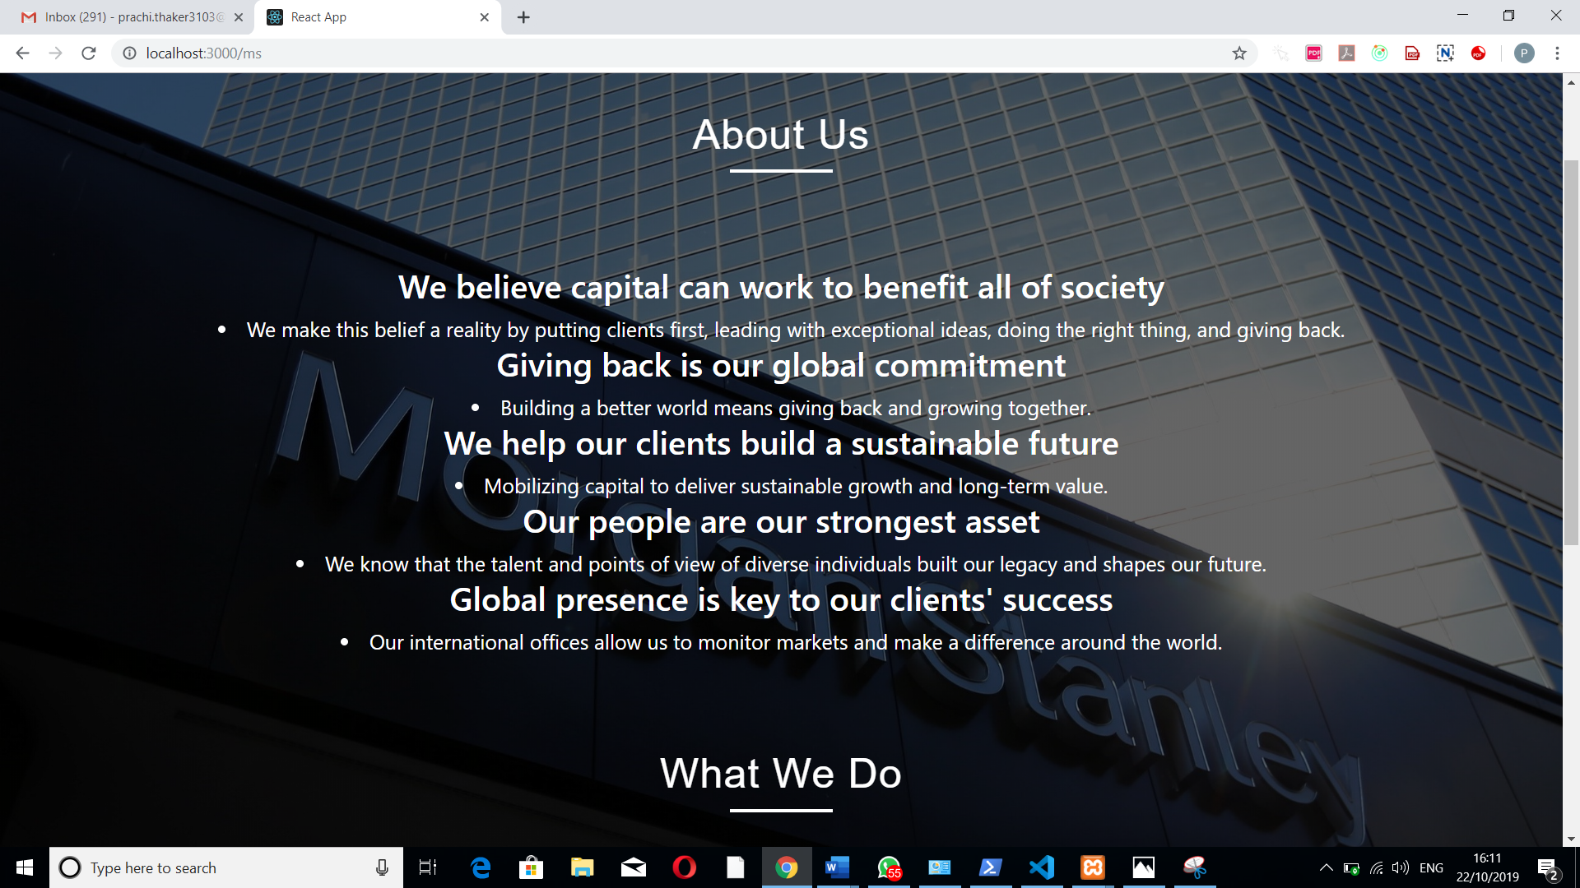

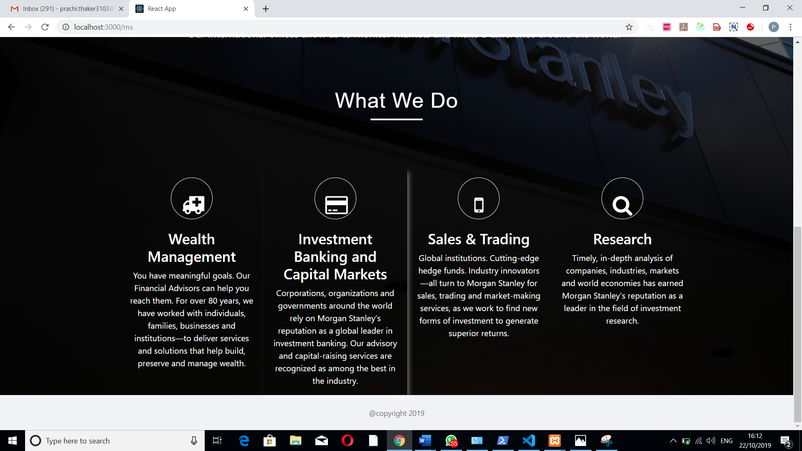

**Login page**

Students login or registeration page for applying for aptitude tests.Students have only one hour of time for giving the test.After one hour they will be automatically logged out.

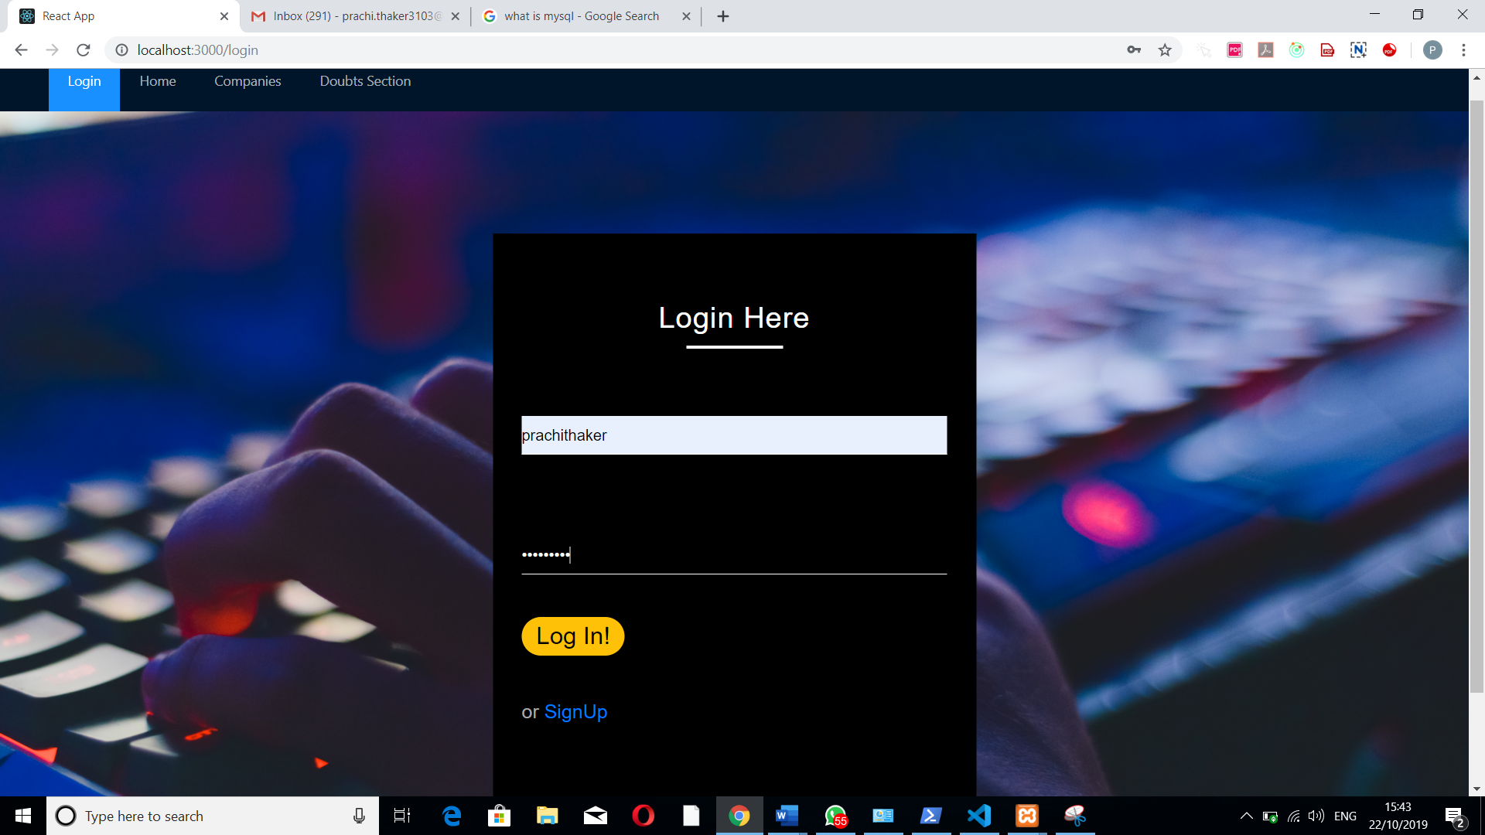

Users login database with there last login date and time and date of joining date and time

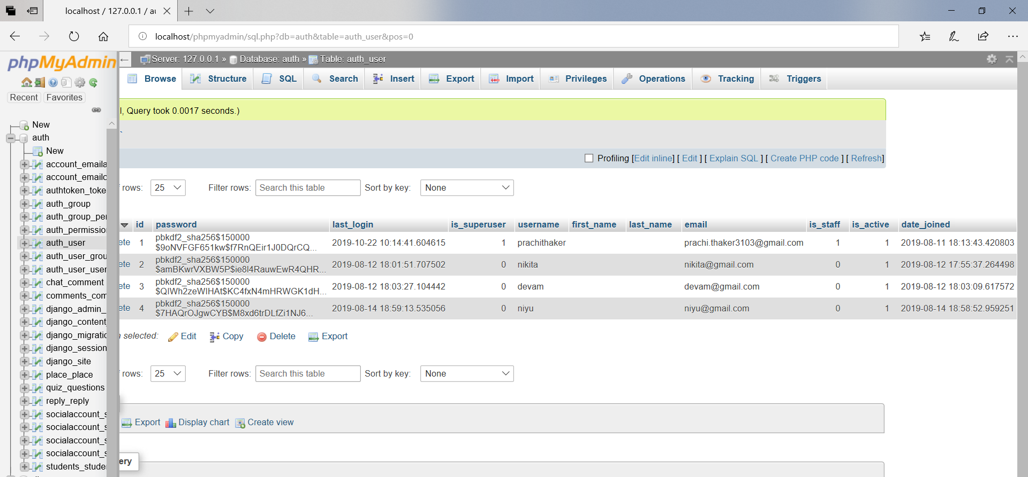

**Students Detail page**

Students need to fill their details before applying for aptitude test. Details include the following fields

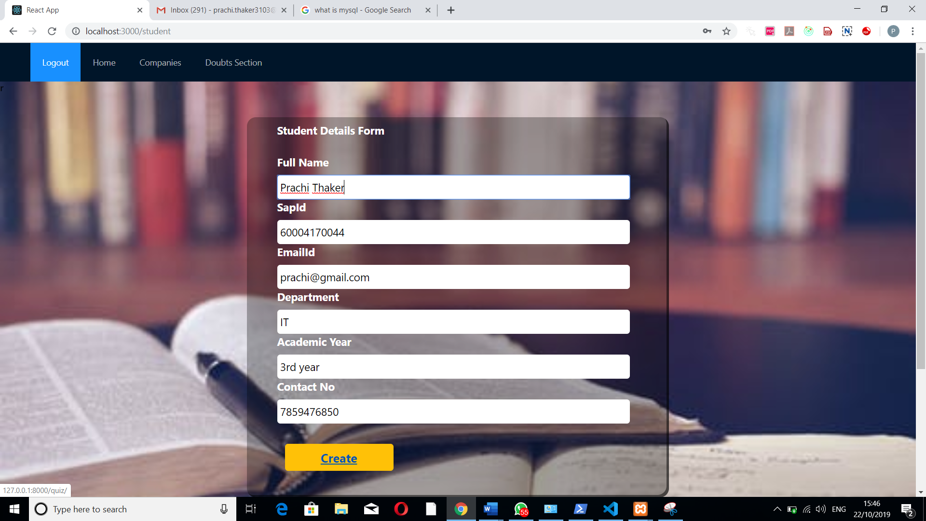

Students details database arranged in ascending order of their sap id.

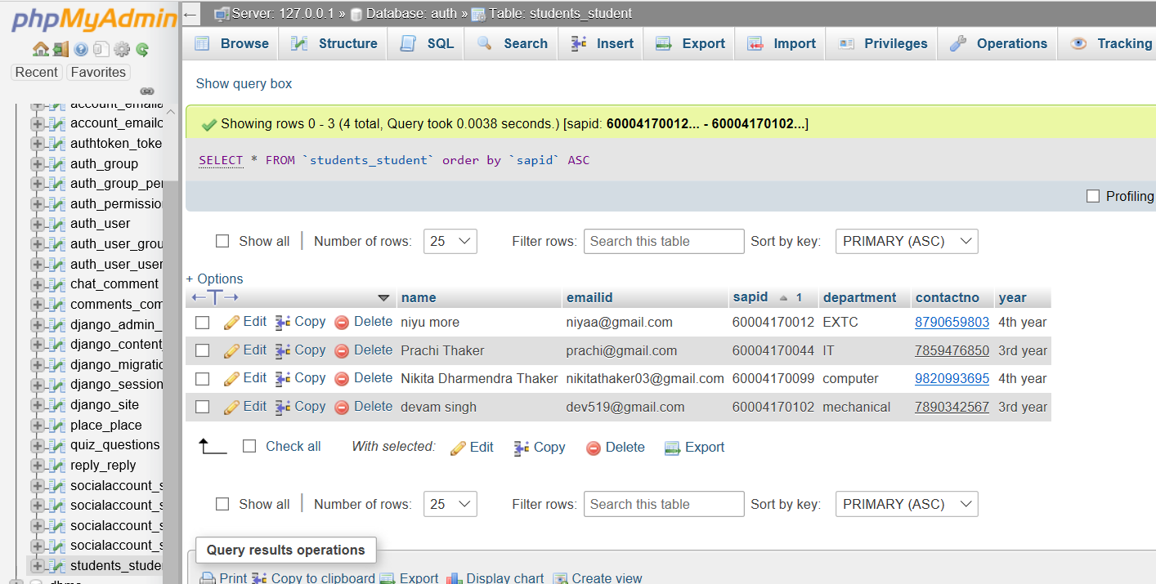

**Quiz Page**

After filling the details the student will get a variety of different topics that they are interested in to, give its tests. Here are some topics listed below

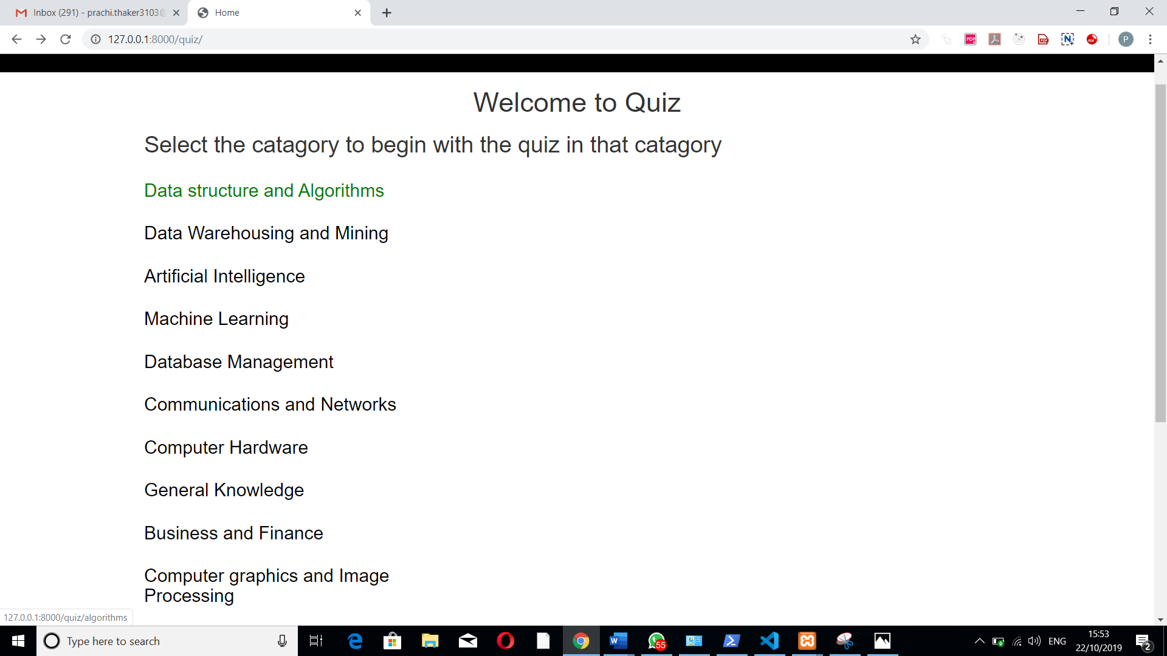

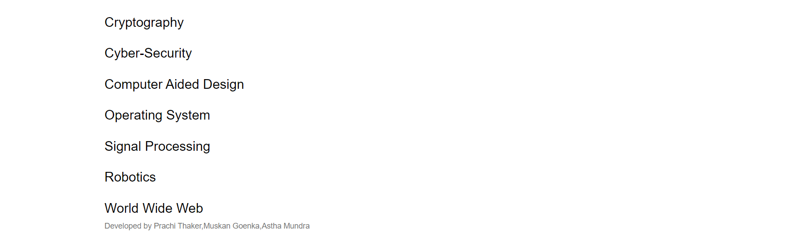

**Questions Page**

Every topic consists of 15 questions.The marks will be calculated on the basis of number of questions attempted.Here are questions of Data Structure and Algorithms.

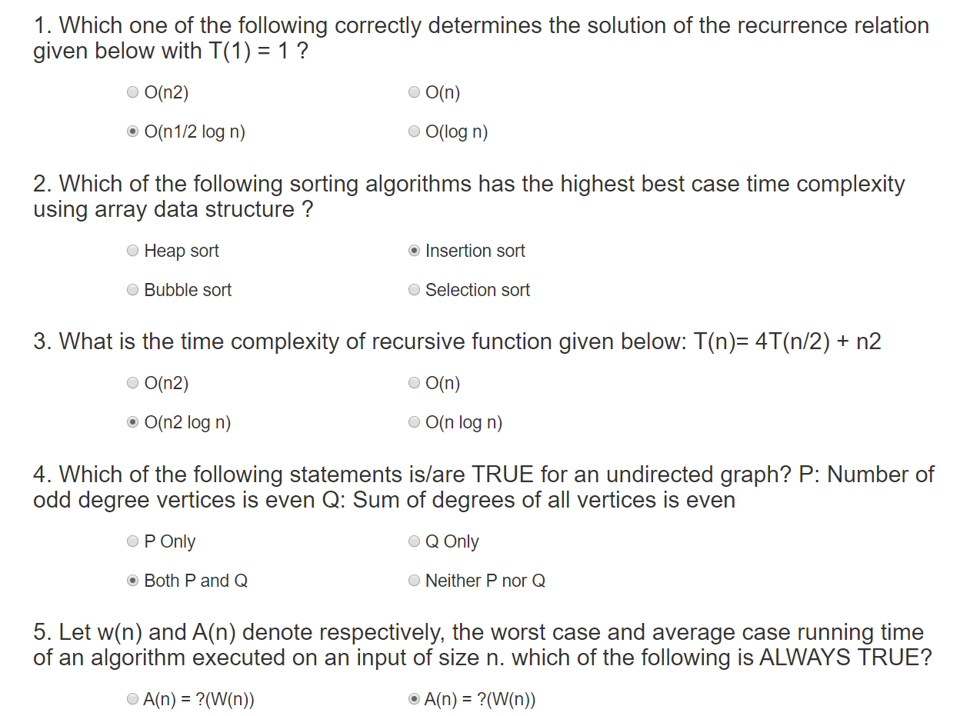

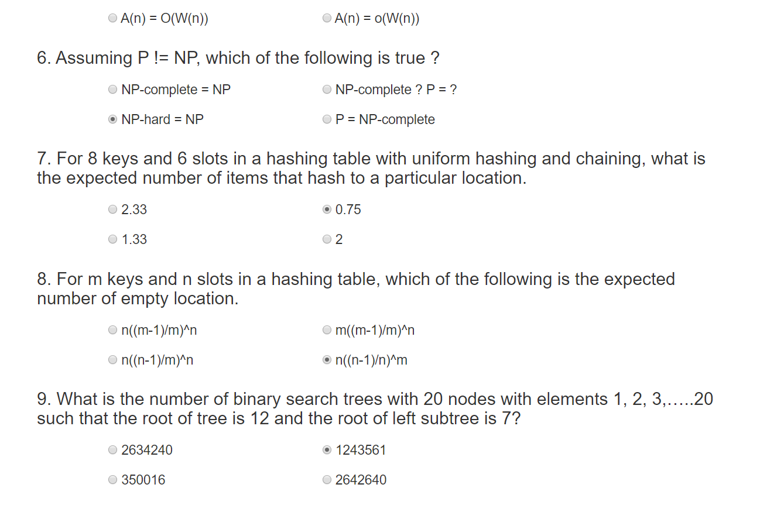

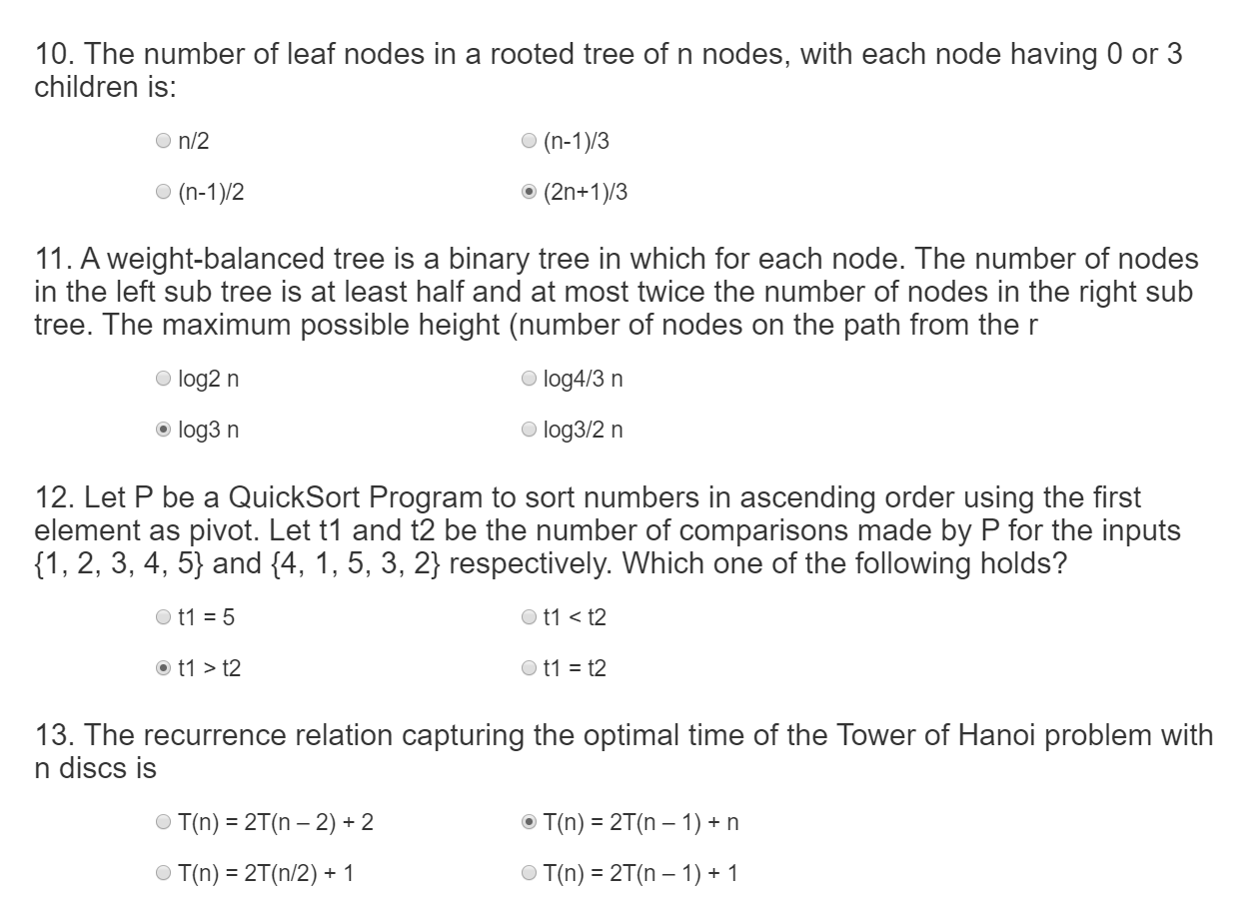

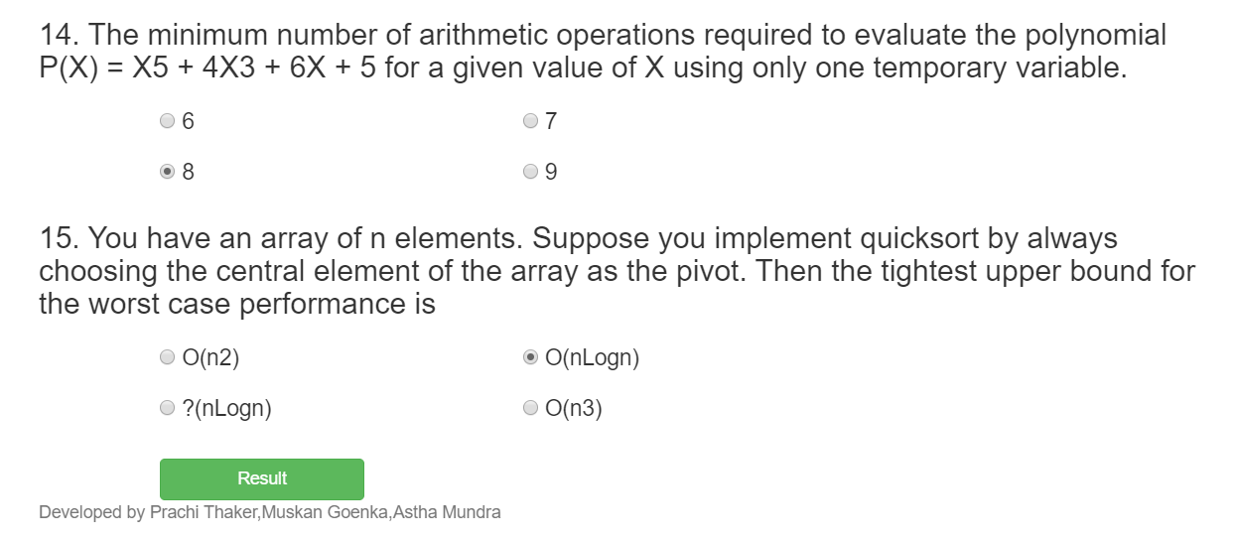

Questions database with questions of different category arranged in descending order of questions

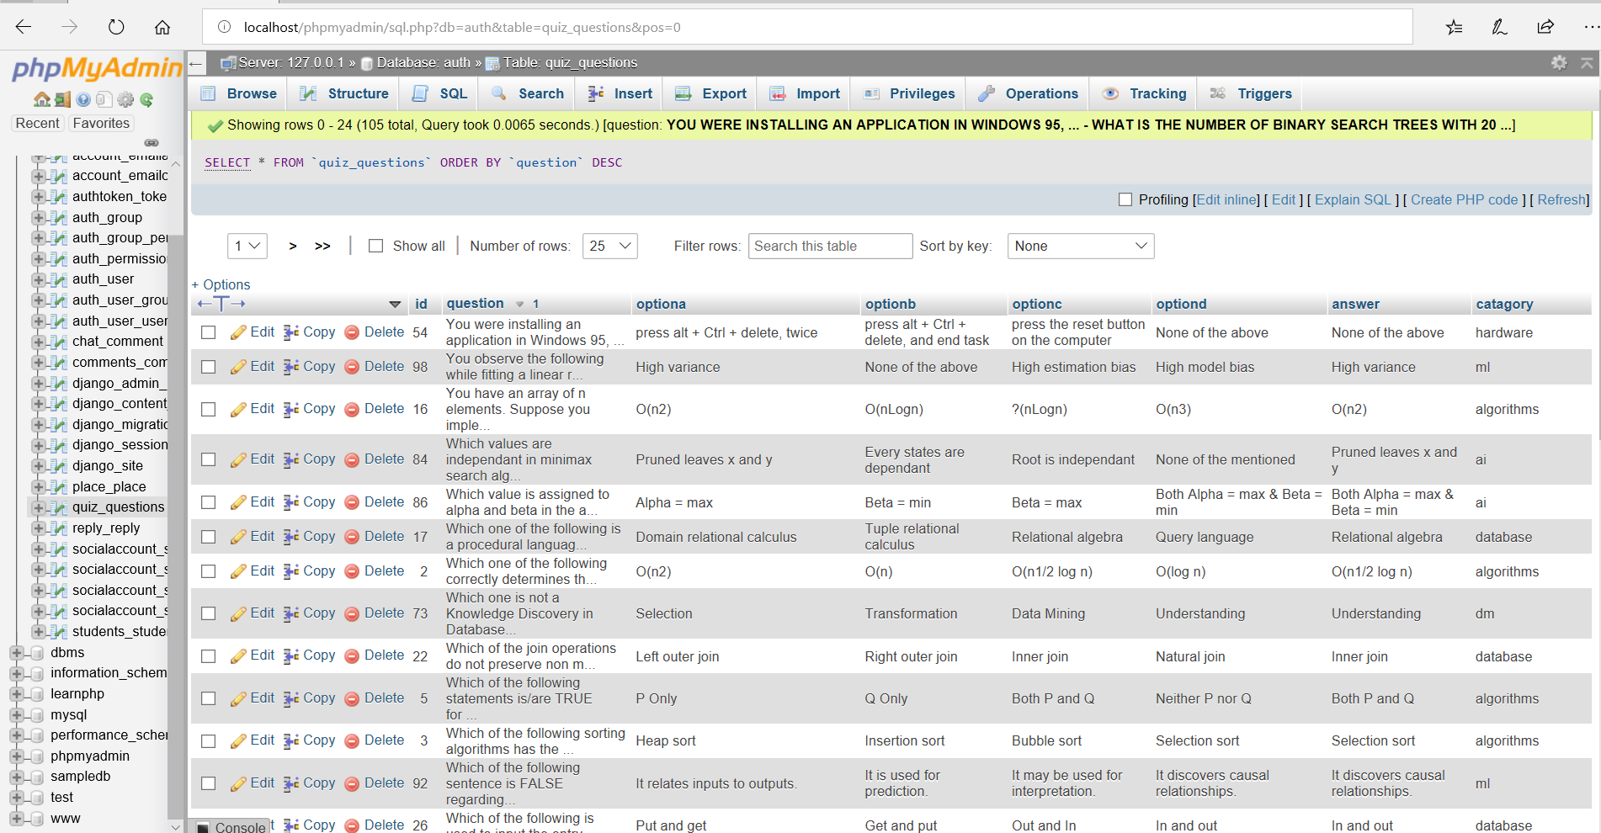

**Result Page**

This page calculates students score and his/her efficiency in respective topic.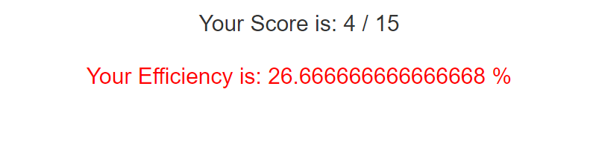

**Doubts Session**

Students can write there doubts on this page.This page will be accessed by teachers as well and the doubts will be solved by them.

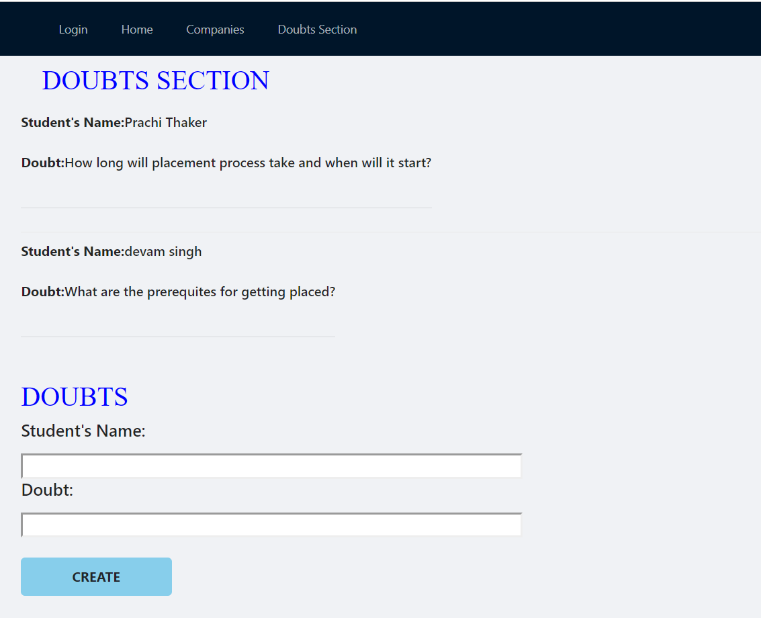

Doubts database of students

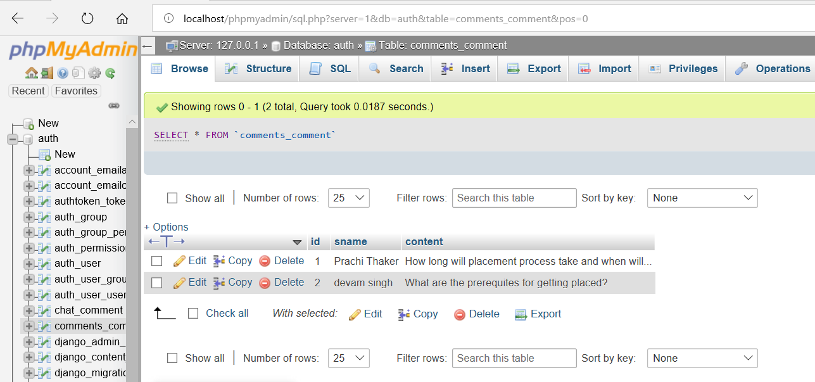

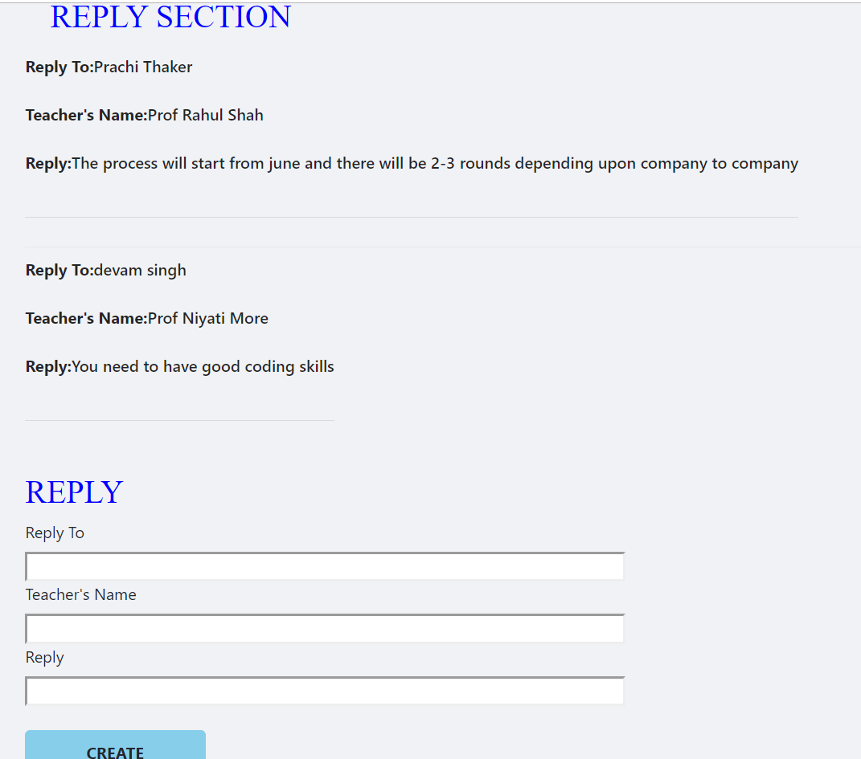

Teachers database with replies to students

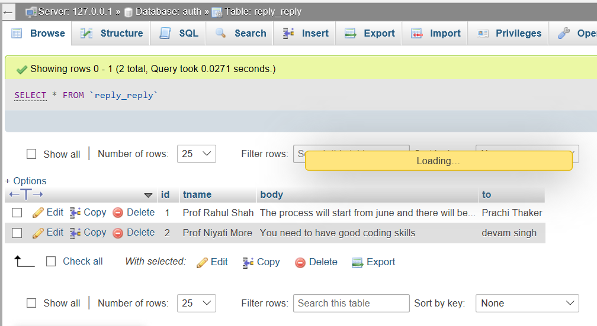

**CONCLUSION**

From a proper analysis of positive points and constraints on the component, it can be safely concluded that the product is a highly efficient GUI based component. This component can be easily plugged in many other systems. Also. the component is user friendly. Generally the Training and Placement Officer’s of the colleges has to face a lot of problems in management of the students information.This all information has to be managed manually. So there is a need to develop a system that can solve the mentioned problem. This software comes with just that solution.